*Warsaw, 24th January 2019*

**17.5% growth of the long-term car rental market**   
**in 2018 – a new record set by the industry**

**Long-term rental boosted the growth of sales of new cars last year**  
**in Polish showrooms**

**Having achieved a record growth rate in long-term car rental in Poland in the third quarter, the industry closes the entire 2018 with a new record high. According to the data published by the Polish Vehicle Rental and Leasing Association (Polski Związek Wynajmu i Leasingu Pojazdów - PZWLP) after the fourth quarter, the dynamics of development of long-term rental were at a level of 17.5% y/y in 2018, which means that now this is the highest ever figure recorded by this organisation. Long-term rental companies purchased 23.4% more new passenger cars than the previous year, clearly running ahead, in this respect, of their competitors in company car financing - purchase with the use of own funds, loan and traditional financial lease. What is more, they significantly contributed to the very good results of the total sales of passenger cars in 2018. Over 45,000 more new passenger cars left Polish showrooms last year than in 2017. 1/3 of this growth of sales was generated by the long-term rental industry, which purchased 15,500 more cars as compared with the preceding year. The car rental industry represented in PZWLP closed 2018 with a 16.1% y/y growth.**

The automotive market in Poland has recorded another very successful year. The sales of new cars exceeded the symbolic barrier of 0.5 million vehicles in 2018, to reach the level of 532,000 cars, i.e. the highest figure this century. The number of cars that left Polish showrooms was 9.35% higher than the previous year. We perform very well against the entire European Union and we have reasons to feel satisfied. According to a report of the European Automobile Manufacturers’ Association (ACEA), the sales of passenger cars in the entire EU grew by as little as 0.1% last year.

As for some time now, the high sales of new cars in Poland have been driven primarily by companies. They purchased as much as 72.3% of all cars in 2018 and their share in this respect continues to grow – last year it increased by 2.6% as compared with 2017.

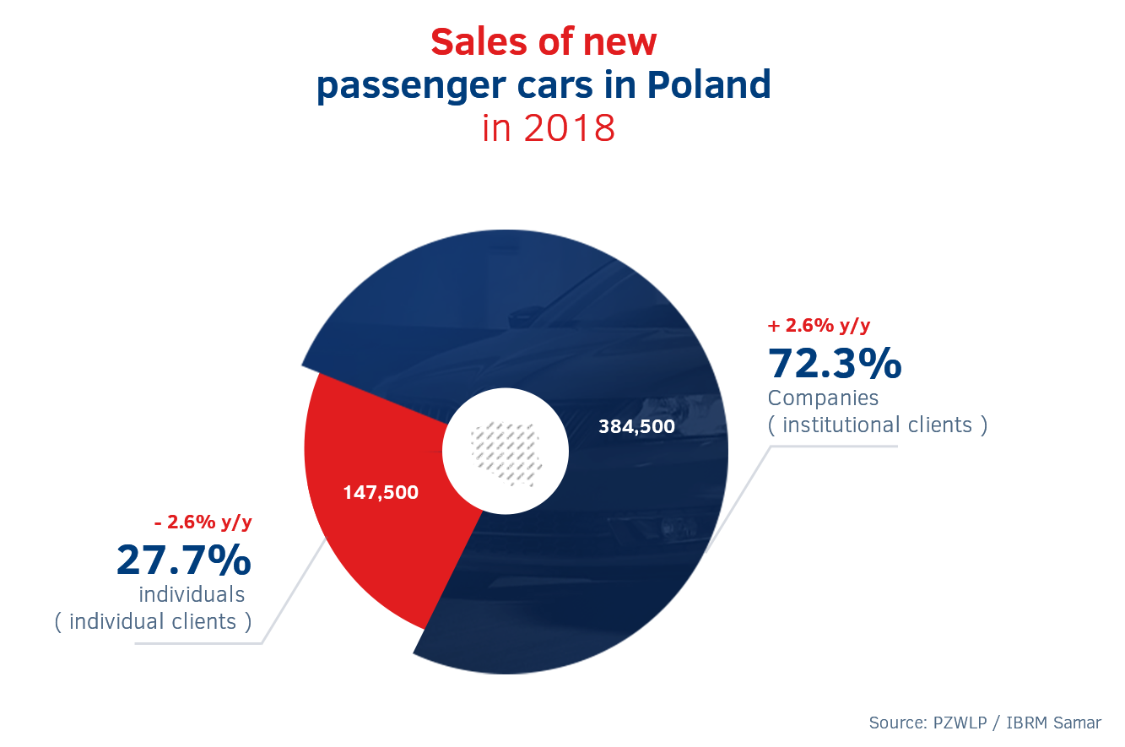

**Sales in showrooms are growing mainly owing to companies, with the sales of cars**   
**to companies boosting long-term rental**

2018 showed very clearly how important the purchase of cars by companies is already now for the condition of the automotive market in our country. In principle, it was only companies that contributed to the fact that the sales of cars exceeded the level recorded in 2017 by 45,500. The sales to individual clients grew by just … 26 cars. In other words, the market would have stood still but for the purchases by companies. Furthermore, it is worth noting that the market growth by 45,000 generated entirely by institutional clients was due, in as much as 1/3, to the growth of purchases of new passenger cars by the long-term rental industry, which bought 15,500 cars more than in the preceding year.

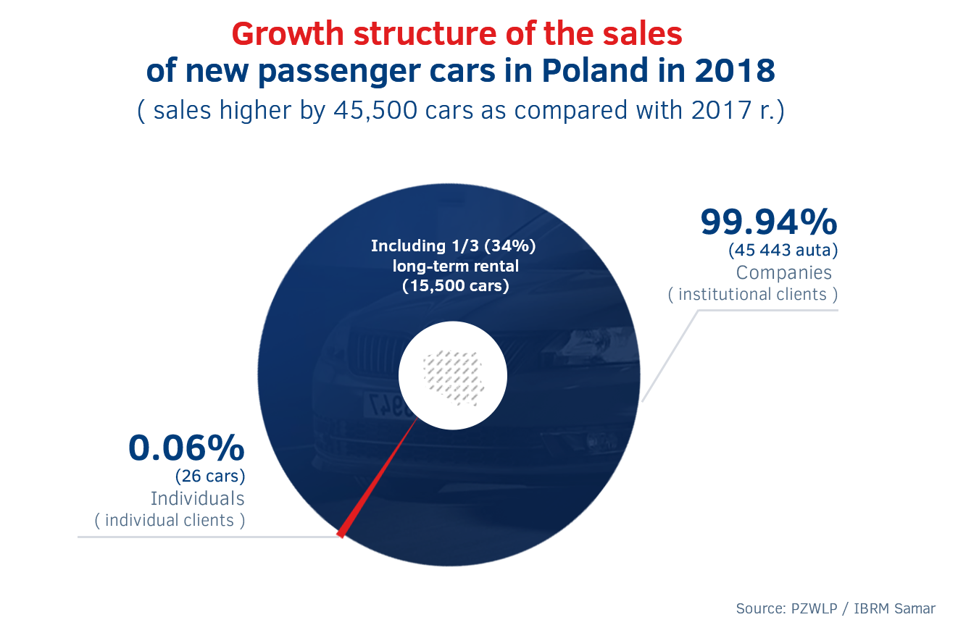

**Long-term rental is growing at the fastest rate, increasing its share in the sales of cars to companies**

According to the data of IBRM Samar, companies purchased 384,500 new passenger cars in 2018. More than every fifth new passenger car purchased at that time by companies was in long-term rental. The long-term rental industry purchased 81,800 cars, which is 23.4% (15,500) more than the previous year, reaching a 21.3% share in the total sales of passenger cars to companies. It is worth noting that the share of long-term rental in this respect increased by 1.7% over the year.

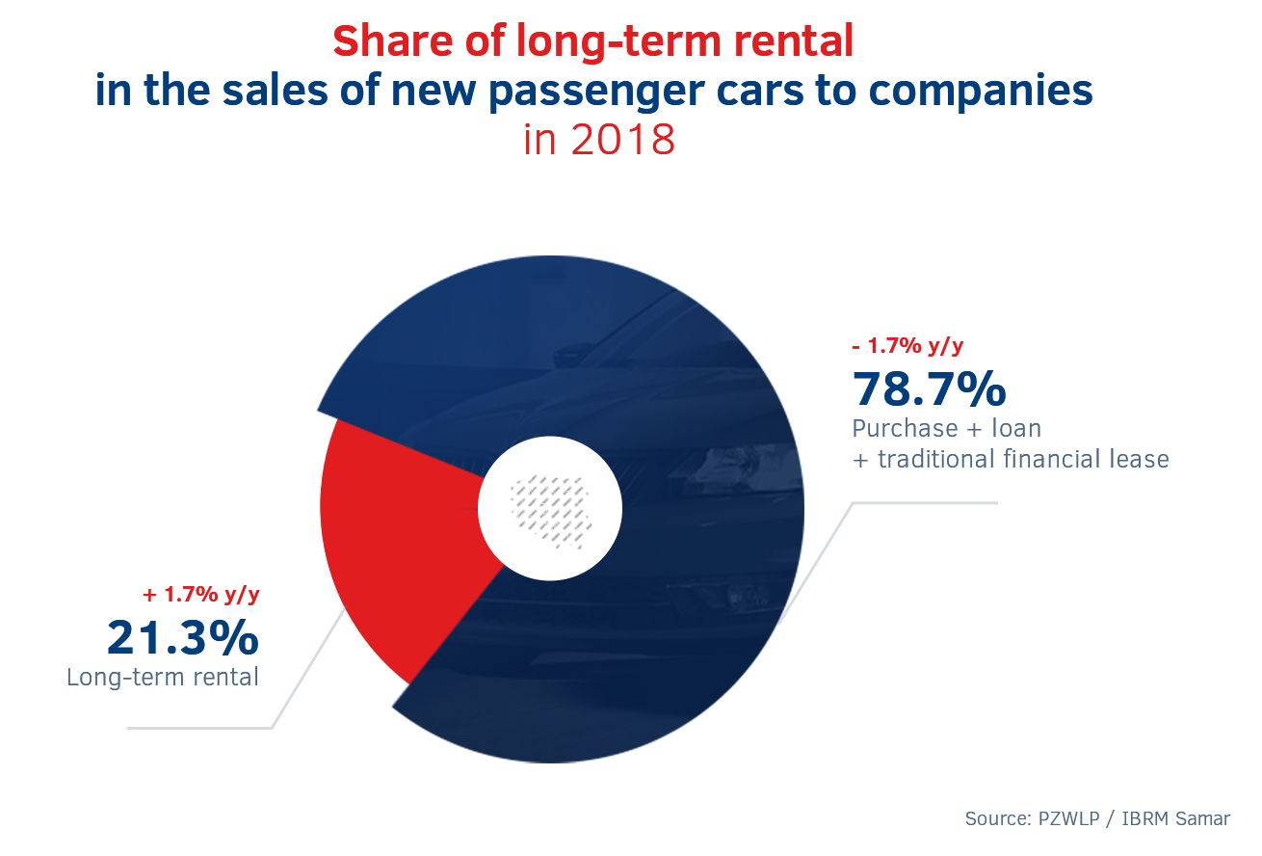

Among the company car financing forms available on the Polish market, long-term rental developed at the definitely fastest rate in 2018, as the number of new passenger cars purchased by this industry was 23.4% higher than the previous year. For the sake of comparison, companies bought 11% more new cars with the use of their own funds, loans or traditional financial lease taken in aggregate. What is more, the sales growth dynamics increased as compared with 2017, although slightly, i.e. by 0.6%, only in the case of long-term rental. In the case of the purchase of new cars using own funds, loans or traditional financial lease taken in aggregate, these dynamics were much lower, i.e. 8.8% lower, than the previous year.

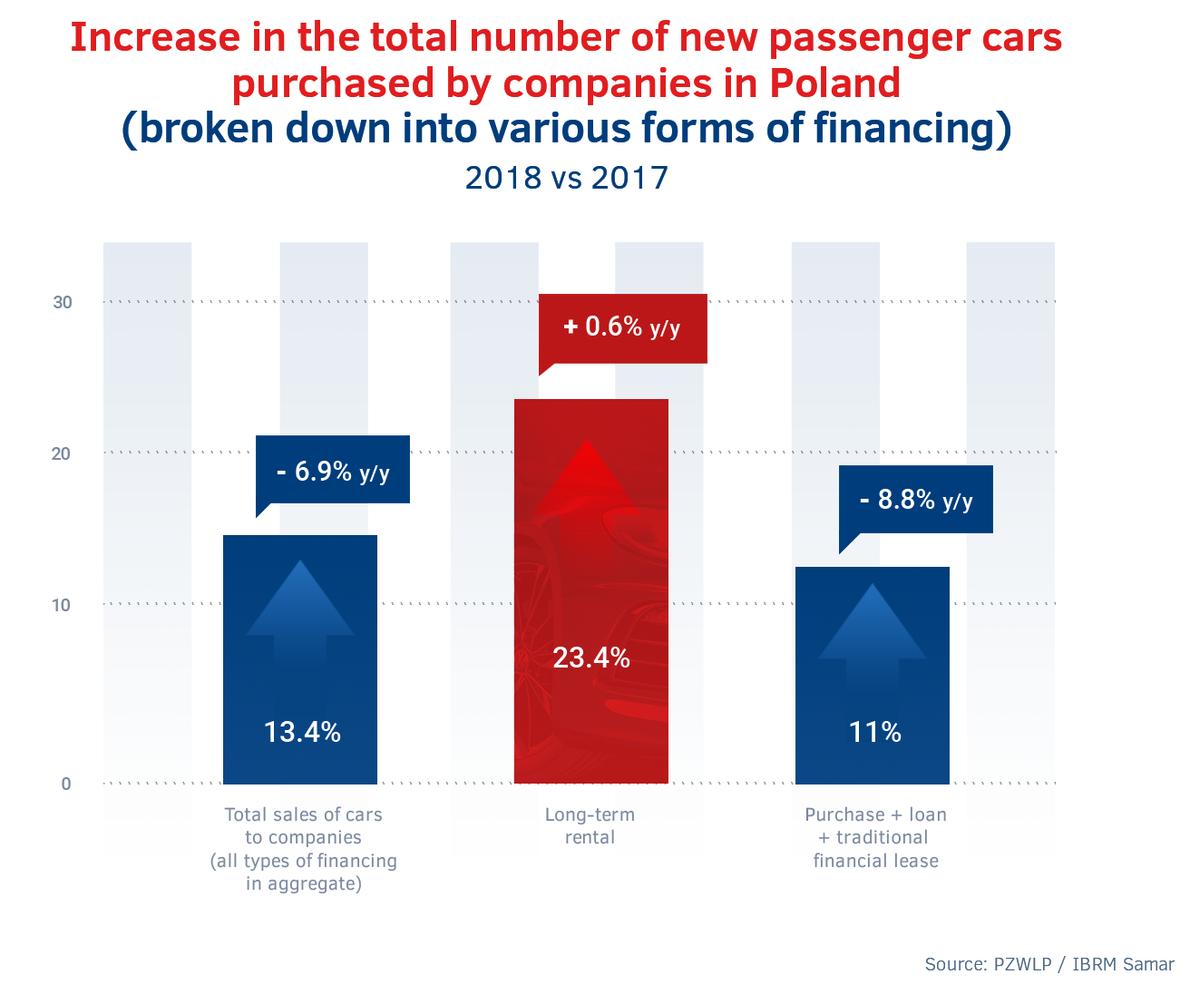

**New record high industry growth rate – achieved already three months after the first one was set**

Having regard to the most important factor in the case of long-term rental, namely the total number of cars under the Full Serwis Leasing scheme, the industry growth rate was on the increase in 2018 for another year in a row, to reach as much as 17.5% y/y at the end of the year – the highest ever result in the history of market analyses conducted by PZWLP for over nine years. Interestingly enough, it was the second historical record achieved last year – the first one was set after Q3 of 2018. The dynamics of growth of the long-term rental market (the total number of cars under the Full Serwis Leasing scheme) in 2018 was nearly 4.5% higher than the previous year, and more than 50% higher than two years ago.

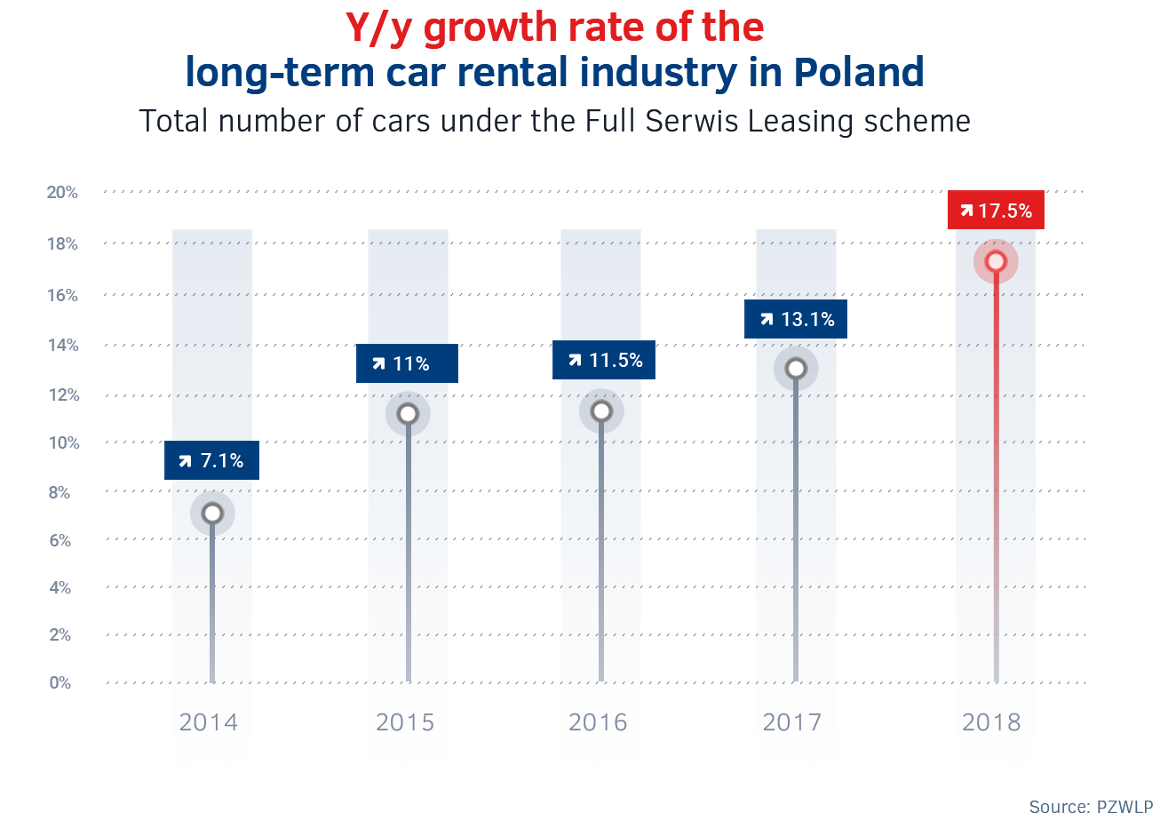

*PZWLP’s data clearly shows that 2018 was the best year in the history of long-term car rental in Poland* – says Grzegorz Szymański, President of the Management Board of PZWLP, CEO of Arval Polska. – *The really impressive market development rate and an increase in the registrations of new cars, which was considerably faster than in the case of competitive forms of car financing, is primarily an effect of the fact that long-term rental has been entering the small and medium-sized business sector in an increasingly visible manner. Savings, as compared with competitive solutions, the fixed nature of costs involved in the financing of vehicles and their comprehensive support and simply convenience are the advantages of long-term rental that at present win over also smaller companies. Long-term rental, despite still being a relatively new service in Poland, not only is starting to play a key role for the fleet sector, but also has an impact on the condition of the entire automotive market in our country. It is worth noting that as much as 1/3 of the growth of the total sales of new passenger cars in Poland in 2018 were generated by our industry.*

At the end of December 2018, there were nearly a total of 188,000 (187,672) cars* in the aggregate fleet of long-term rental companies belonging to the PZWLP (representing ca. 80% of the market),   
a vast majority of which (81.6%) were covered by the Full Serwis Leasing scheme. The most popular cars included: Skoda Octavia, Volkswagen Passat, Ford Focus and Skoda Superb.

**Share of diesel engines still on a decrease**

Data as at the end of 2018 shows a clearly diminishing share of cars with diesel engines in long-term rental fleets in Poland. At the end of December, cars powered with a compression-ignition engine constituted barely more than 60% of the overall number of cars (61.4%), and their share dropped by nearly 5% (4.9%) over the year. Diesel-powered cars were less popular than primarily petrol-engine powered cars, which constituted as much as over 1/3 (37%) of cars at the end of last year, and their share increased by 4.3% over 12 months. The share of cars with an eco drive system, i.e. hybrid or electric drive, is also growing. These types of vehicles accounted in aggregate for 1.6% (an increase by 0.6% y/y) in long-term rental in PZWLP companies’ fleets at the end of 2018, with their number totalling over 3 000 (3 058), of which hybrid cars constituted an absolute majority (2 995), while electric cars were still a margin – barely 63 vehicles. Nevertheless, the number of hybrid and electric cars is growing very quickly – it has nearly doubled over the year.

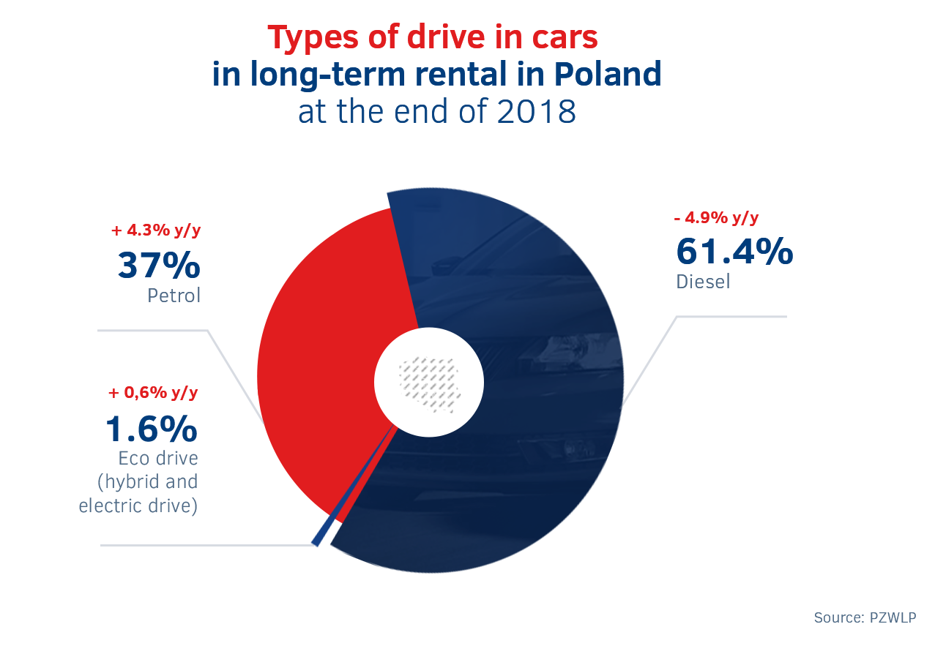

The average carbon dioxide emission in the case of new passenger cars purchased by PZWLP companies in the fourth quarter of 2018 for long-term rental purposes was lower   
(by 4.8% and 6.4 g/km) as compared with the same period of the previous year and amounted to 127.3 g/km (in the fourth quarter of 2017 it was 133.7 g/km). In the case of commercial cars, the average emission was 156.5 g/km, being thus 3.6% (5.5 g/km) higher as compared with the level from the previous year.

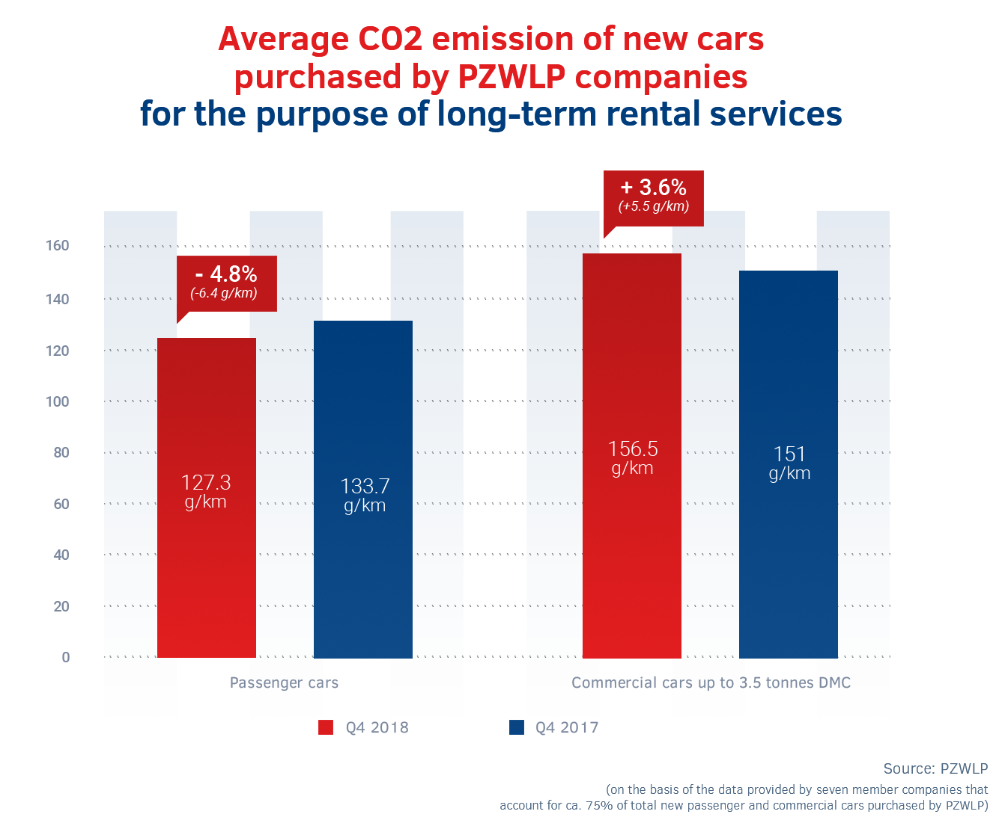

**Car rental industry with a 16.1% y/y growth**

The car rental industry represented in PZWLP by seven large Polish and international chain car rental companies recorded a 16.1% y/y growth in 2018. By the end of March, the total fleet of Rent-a-Car companies in PZWLP** in short-term rental services (1-30 days) and medium-term rental services (1 month – 2 years) included nearly 17,500 (17,497) cars.

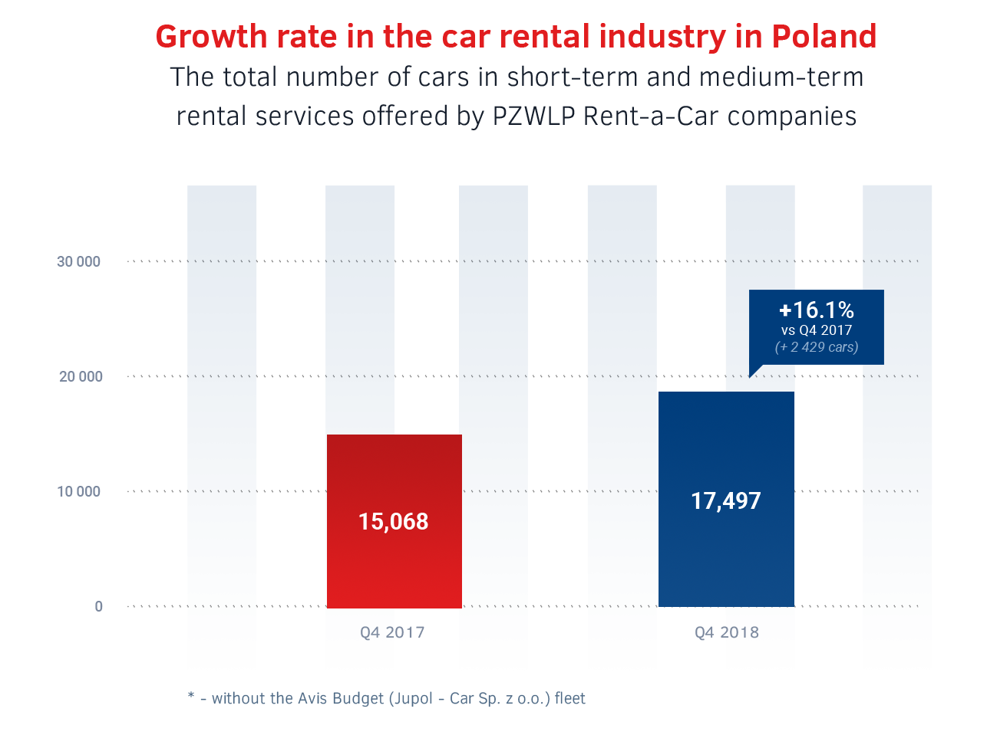

**Year marked by major changes in the regulatory environment**

2018 was a year of changes in the broadly understood legal environment for the long-term car rental industry. Regulations changing during the year or amendments announced to be introduced from 2019 did have an impact on the operation of the industry, but did not affect the overall development of the market and the growth of the sales of services offered. This refers to, among other things, the introduction, starting from September, of the new Euro 6d-Temp exhaust emission standard for all new cars sold. The implementation of the new standard has caused considerable confusion in the automotive market throughout the EU and in practice not only implied changes in the specification (and often engines) of car models offered on the market, but also reduced the availability of certain cars or lengthened the waiting time for the delivery of the car by dealers on a temporary basis. Furthermore, the industry also focused on the preparation for the new IFRS 16 standard to be implemented from 2019, concerning companies reporting in accordance with the International Accounting Standards, which in practice usually are large international entities. Finally, initial information appeared around mid-year on material amendments to tax regulations in Poland planned from 2019, concerning passenger cars used by companies.

*The statistical data of PZWLP once again demonstrate that the long-term car rental industry in Poland is one of the most resistant to any regulatory changes or temporary fluctuations in the market situation* – says Leszek Pomorski, PZWLP Management Board Member, President of Alphabet Polska. – *Both the announced amendments to regulations and the introduction itself of a new exhaust emission standard are phenomena which potentially could have had a significant impact on the market. They proved neutral, nevertheless, in the case of long-term rental - the new emission standard did not result in disruptions to car deliveries to clients or in increased demand in the third quarter of the year, before it was introduced. Likewise, the new tax regulations, which took effect at the beginning of 2019, have not resulted, in the case of long-term rental, in increased car purchases “for store” by companies, before the new regulations were implemented. The industry growth rate was, of course, significantly higher than in the preceding year and in previous years. The very good results recorded by the industry are, nevertheless, due to an upward trend in the popularity of long-term rental that has been observed for a few years now rather than to the impact of one-off factors.*

**¼ of all cars sold in Polish showrooms purchased by PZWLP Members**

Taking into account the overall activities of 20 companies belonging to the Polish Vehicle Rental   
and Leasing Association (PZWLP), that is primarily short-, medium- and long-term car rental services, and also the financial lease of cars, PZWLP companies purchased a total of 129,500 new passenger cars in the entire year 2018. This means that nearly 1/3 (33.7%) of new passenger cars purchased in 2018 by entrepreneurs in Polish showrooms and 1/4 (24.3%) of cars sold at that time in total (to both institutional clients and individuals) was acquired by companies belonging to PZWLP ***.

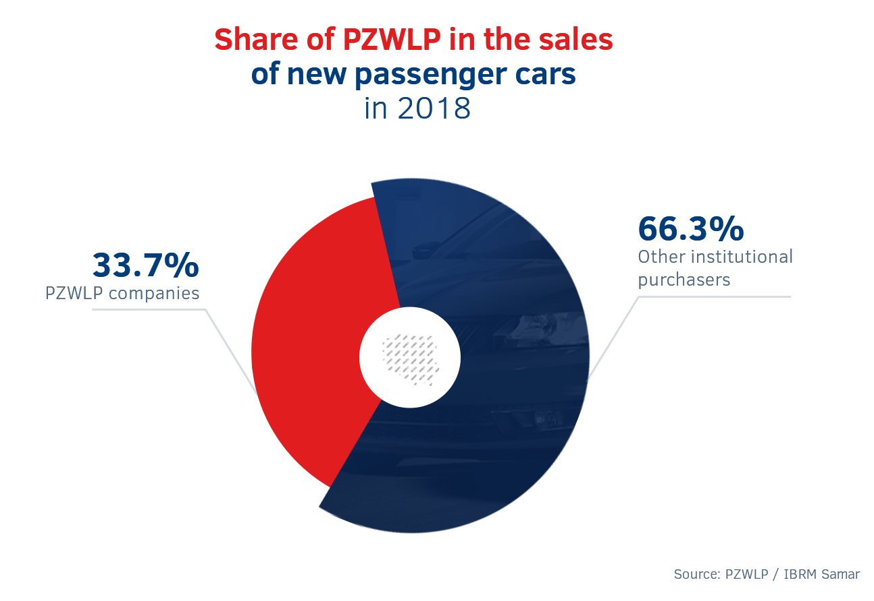

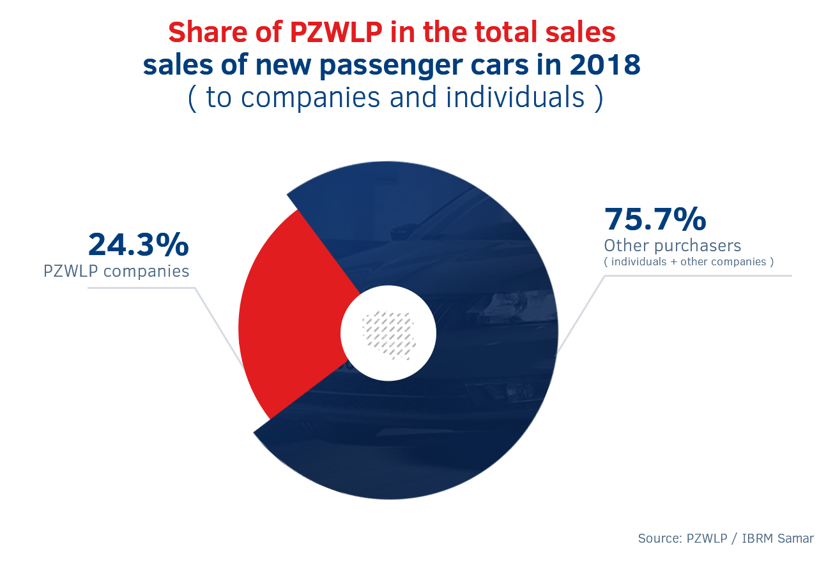

***\**** *— without the Athlon Car Lease fleet*

***\*\**** *— without the Avis Budget / Jupol - Car fleet*

*\*\*\* — PKO Leasing and mLeasing are also members of ZPL (Polish Leasing Association).*